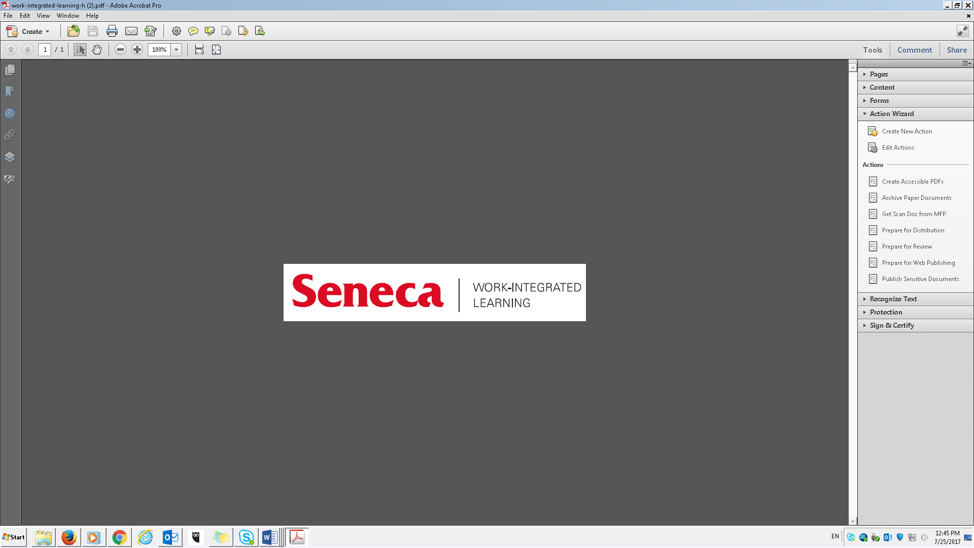

**Individualized Learning Plan Template Name: Khai Thanh Phan Student Number: 100901164**

**Workplace: Seneca College (Center for Development of Open-Source Technology – CDOT)**

|  |  |  |  |  |
| --- | --- | --- | --- | --- |
| **Learning Goal**  I want to learn…. | **Strategy**  I will learn by… | **What Success May Look Like**  Accomplishing my goal may look like… | **Target Date** | **Post Co-op/Work Term Evidence of Success**  I will know I am successful when…(Provide specific work examples) |
| **GOAL #1:**  I want to learn more about operating system in Linux, especially about the command-line that I can use to operate the work without GUI. | I will challenge myself by using as much command-line as possible, no matter which situation. Especially in Linux, it is designed so that about 95% of the task can be done in terminal. | I know I will achieve the goal when I can freely use the command line system without have to look at Google (except for new command-line) or need a UI to do the work. | March 1st, 2021 | When I am confident to work with other colleagues, see what they are doing and understand it. There might be some new command that I do not know, but it should be easy to recognize or understand the function just by looking at its name or library. |
| **GOAL #2:**  I can use and work on Open-Source software, understand most of the file type and know the step I should do to build or compile the software. | I will be learning this by discovering as many Open-Source software as possible that I can use to help my work progress while I am at OSTEP, it does not have to used, but at least I have a chance to discover it and get in touch with it. | When I can be confident to work with any available Open-Source software in the market. Previously, I was very scare to touch them because it is a well-developed code from a team, and I found myself not “talented” enough to read and understand it. | April 30th, 2021 | I am no longer scare of using or reading that Open-Source software anymore. These sources will be using a lot in the future as part of a development plan for any program. |
| **GOAL #3:**  Get familiar with weekly meeting at the beginning of the week and end of week meeting report. | Trying to summarize and sum up the work I did during the week and the work I planned to do for the week to keep track of the progress | When I can foresee and carefully plan how much task I can carry on this week and what are my flexibility on that, especially task that can be arrange for next week if that is possible. | March 1st, 2021 | When I can go to any workplace and have a progress target for myself. In order to achieve a bigger target, I have to set many small targets and strictly following that in order to reach the end. |
| **GOAL #4:**  Take my time to work on a program, understand and carefully estimate the work, do not rush to the completion. | I will learn by taking my time at CDOT and enhance the program there. Since it is an unpaid internship, I can spend as much time as I need without any restriction and that give me the ability to understand and work on the project well without any pressure. | When I can spend as much time as I need (but never take this as an advantage to get lazy) and understand the details of the works | April 30th, 2021 | When I can clearly understand and still remember the work after it. It shouldn’t be where I remember it for the work and then forget it completely after that. |
| **GOAL #5 (based on a program learning outcome):**  Continue the life-long learning process of acquiring new skills and knowledge through formal and self-directed means using information and learning resources. | Use as much Open-Source software and data as possible as part of my learning resources for future project that might require that | When I have less trouble finding a solution for a project or a work, besides from my classroom learning skills. Coding and Programming is not a job for one person, and in the world, there might be some people who interest in that but only be able to develop a part of it, so my job is to collect them and put them all together to complete the work. | N/A | When I can use multiple open resources and put them altogether into a project and have it run |